**Evaluation**

A screenshot of the confusion matrix can be seen below:

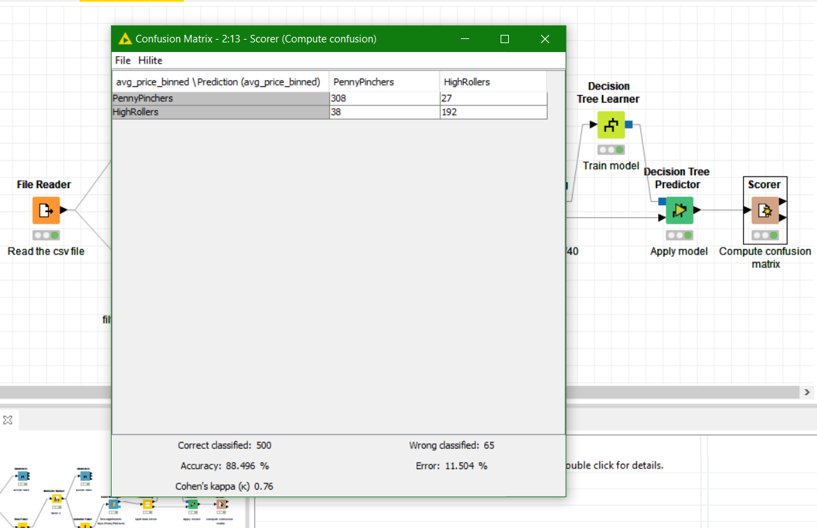

As seen in the screenshot above, the overall accuracy of the model is 88.496%.

**Confusion Matrix –**

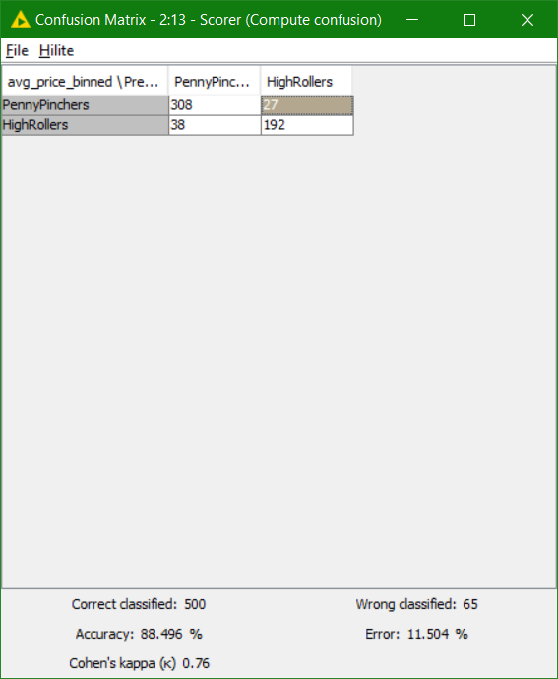

This shows that there are total **65** Wrong classified predictions (**38+27 = 65**)

Of the 335 Penny Pinchers in the test data set >>

**308 (91.9%)** of them were correctly predicted as Penny Pinchers by decision tree model.

**27 (8.1%)** of these Penny Pinchers were incorrectly predicted as High Rollers.

Of the 230 High Rollers in the test data set >>

**192 (83.5%**) of them were correctly predicted as High Rollers by decision tree model.

**38 (16.5%)** of these High Rollers were incorrectly predicted as Penny Pinchers.

Row 150 is highlighted. Wrong Prediction (Predicted – PennyPinchers, Actual – HighRollers)

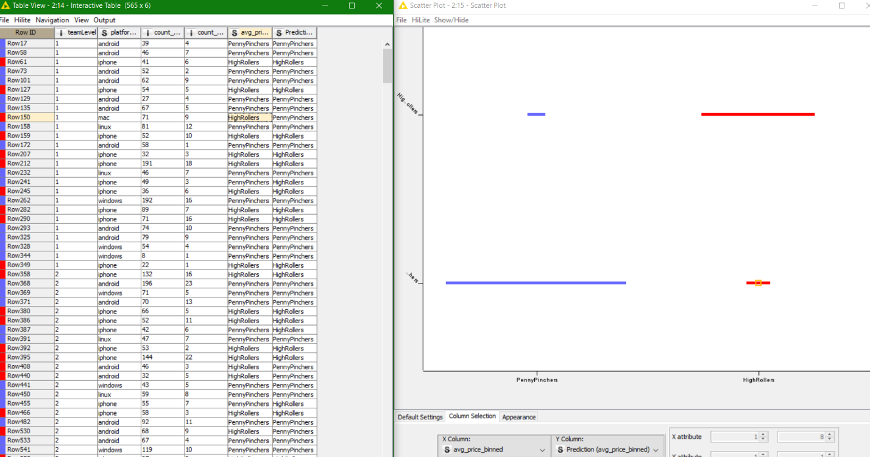

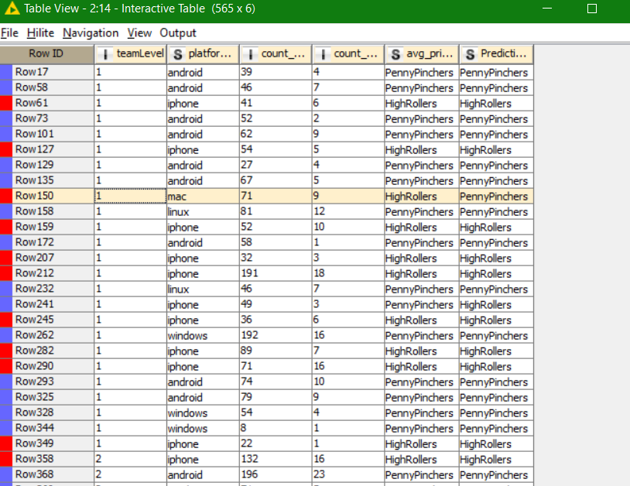

ROW 150 highlighted above is shown in the scatter plot below

The **wrong prediction** **are small horizontal** **blue line and the red line**. Both denote wrong Predictions.

The below graph means that if on both axis we have highRollers and Penny Pinchers then the prediction is good and since the success rate is 88.5% that’s why we have long horizontal red and blue lines.

